**GYM Management System**

**A PROJECT REPORT**

**for**

**Mini Project-I (K24MCA18P)**

**Session (2024-25)**

**Submitted by**

**Gourav Chauhan**

**(202410116100077)**

**Manish Kumar**

**(202410116100113)**

**Harsh Singh**

**(202410116100085)**

**Submitted in partial fulfilment of the**

**Requirements for the Degree of**

**MASTER OF COMPUTER APPLICATION**

**Under the Supervision of**

**Mr. Arpit Dogra**

### Assistant Professor



**Submitted to**

**Department Of Computer Applications**

**KIET Group of Institutions, Ghaziabad**

**Uttar Pradesh-201206**

**CERTIFICATE**

Certified that **Gourav Chauhan (202410116100077), Manish Kumar (202410116100113), Harsh Singh (202410116100085)** has/ have carried out the project work having “**Gym Management System**” (**Mini Project-I, K24MCA18P**) for **Master of Computer Application** from Dr. A.P.J. Abdul Kalam Technical University (AKTU) (formerly UPTU), Lucknow under my supervision. The project report embodies original work, and studies are carried out by the student himself/herself and the contents of the project report do not form the basis for the award of any other degree to the candidate or to anybody else from this or any other University/Institution.

**Mr. Arpit Dogra Dr. Arun Kr. Tripathi**

**Assistant Professor Dean**

**Department of Computer Applications Department of Computer Applications**

**KIET Group of Institutions, Ghaziabad KIET Group of Institutions, Ghaziabad**

**Gym Management System**

**ABSTRACT**

The Gym Management System is a comprehensive platform designed to streamline the operations and enhance the experience of gym members and administrators. This system offers essential functionalities such as user login and signup to ensure secure access and personalized services. Users can explore details about various **fitness classes**, ranging from yoga to high-intensity interval training, and view schedules tailored to their needs. Additionally, the system categorizes **workouts into different types**, such as strength training, cardio, and flexibility, enabling members to choose routines that align with their fitness goals.

The platform also features an engaging **blog section**, offering articles and tips on health, nutrition, and wellness to keep users motivated and informed. Furthermore, detailed **profiles of trainers**, including their expertise and contact information, allow members to select and connect with the most suitable trainers for their journey.

By integrating these functionalities into a user-friendly interface, the Gym Management System ensures an organized and interactive environment for both gym members and staff. This project aims to enhance efficiency, user engagement, and overall satisfaction within fitness communities.

**ACKNOWLEDGEMENT**

Success in life is never attained single-handedly. My deepest gratitude goes to my

project supervisor, **Mr. Arpit Dogra** for his guidance, help, and encouragement

throughout my project work. Their enlightening ideas, comments, and suggestions.

Words are not enough to express my gratitude to **Dr. Arun Kumar Tripathi**, Professor

and Dean, Department of Computer Applications, for his insightful comments and

administrative help on various occasions.

Fortunately, I have many understanding friends, who have helped me a lot on many

critical conditions.

Finally, my sincere thanks go to my family members and all those who have directly

and indirectly provided me with moral support and other kind of help. Without their

support, completion of this work would not have been possible in time. They keep my life

filled with enjoyment and happiness.

**Gourav Chauhan**

**(202410116100077)**

**Manish Kumar**

**(202410116100113)**

**Harsh Singh**

**(202410116100085)**

**TABLE OF CONTENTS**

**Certificate** ............................................................................................................... 02  
**Abstract** ...................................................................................................................03  
**Acknowledgements** .................................................................................................04

**CHAPTER 1: INTRODUCTION**   
1.1 General .............................................................................................................. 06  
1.2 Overview of the Gym Management System ........... …………………………..06  
1.3 Objectives of the System ................................ ………………………………..06  
1.3.1 Member Benefits ......................................... ………………………………..06  
1.3.2 Administrator Benefits ................................ ………………………………..06  
1.4 Problem Statement ........................................ ………………………………...07  
1.5 Target Audience ........................................... …………………………………07  
1.6 Project Significance ....................................... ………………………………..07  
1.7 Limitations of the System ................................ ………………………………07

**CHAPTER 2: FEASIBILITY STUDY / LITERATURE REVIEW**   
2.1 Technical Feasibility ........................................................................................08  
2.2 Economic Feasibility ........................................................................................08  
2.3 Market Research ...............................................................................................09  
2.4 Existing Gym Management Solutions ..............................................................09  
2.5 Gap Analysis .....................................................................................................09-10

**CHAPTER 3: PROJECT OBJECTIVE**  
3.1 Key Goals of the System ................................................................................. 11  
3.2 User Requirements Alignment ........................... …………………………….11

**CHAPTER 4: HARDWARE AND SOFTWARE REQUIREMENTS**   
4.1 Hardware Specifications ................................................................................... 12  
4.2 Software Tools Used ......................................................................................... 12

**CHAPTER 5: PROJECT FLOW**   
5.1 Development Methodology ................................................................................13-15  
5.2 Data flow and Use Case Diagram.......................................................................16-17

**CHAPTER 6: PROJECT OUTCOME**   
6.1 System Features ................................................................................................ 18  
6.2 User Interface Overview ...................................................................................18-23

**REFERENCES** ………………………………………………………………….. 24

**Chapter 1**

**INTRODUCTION**

1.1 **General**

The Gym Management System is a user-centric platform designed to streamline gym operations and enhance the fitness experience for members. As gyms grow in size and popularity, managing memberships, workout plans, trainers, and class schedules manually becomes increasingly complex. This project addresses these challenges by introducing a digital solution that automates various processes while ensuring user engagement.

1.2 **Overview of the Gym Management System**

The Gym Management System combines essential features like secure authentication, personalized workout categories, class schedules, and detailed trainer profiles. It also incorporates a blog section to provide users with valuable insights on fitness and health trends. The system focuses on delivering a seamless experience for both gym members and administrators, enhancing operational efficiency and user satisfaction.

1.3 **Objectives of the System**

1.3.1 **Member Benefits**

* Simplified access to class schedules and workout plans.
* Availability of diverse workout categories, including cardio, strength training, and yoga.
* Insightful blogs on fitness, health, and nutrition to support members in achieving their goals.

1.3.2 **Administrator Benefits**

* Secure member management through login/signup functionalities.
* Streamlined processes for managing trainer profiles and class schedules.
* Efficient storage and retrieval of data for better decision-making.

1.4 **Problem Statement**

The fitness industry has witnessed significant growth, leading to a surge in gym memberships and demand for personalized services. However, many gyms still rely on traditional manual methods for management, resulting in inefficiencies, errors, and suboptimal member experiences. This project aims to overcome these limitations by developing a robust, automated Gym Management System.

1.5 **Target Audience**

The Gym Management System is tailored for:

* Gym owners and administrators seeking to enhance operational efficiency.
* Fitness enthusiasts looking for an engaging and personalized experience.
* Trainers aiming to showcase their expertise and connect with potential clients.

1.6 **Project Significance**

By automating core processes, the Gym Management System not only improves the day-to-day operations of gyms but also fosters a more engaging and supportive environment for members. It aligns with modern fitness trends by integrating technology into health and wellness practices.

1.7 **Limitations of the System**

* Initial implementation costs may be a barrier for small gyms.
* Dependency on stable internet connectivity for seamless operations.

**Chapter 2**

**FEASIBILITY STUDY**

**2.1 Technical Feasibility**

The gym management system utilizes a combination of front-end technologies (**HTML**, **CSS**, **JavaScript**) and the **Django** framework for the back-end to ensure a reliable, scalable, and high-performance system. HTML and CSS provide a user-friendly interface, while JavaScript adds dynamic functionality such as form validation and interactive features like calendars for scheduling or real-time updates. Django, being a robust Python framework, ensures a secure and scalable back-end that can handle user authentication, member data storage, and class scheduling efficiently. The system leverages Django's ORM (Object-Relational Mapping) to interact with a database, streamlining data management and retrieval. Additionally, the system's modular architecture allows for future extensions, such as adding mobile support or integrating third-party fitness tracking services.

**2.2 Economic Feasibility**

The economic feasibility of implementing this gym management system is promising. The cost of development is relatively low, given the open-source nature of the technologies used (HTML, CSS, JavaScript, Django), which reduces licensing and software costs. The system minimizes the need for manual administrative work by automating tasks such as member registration, class scheduling, and billing, which leads to lower operational costs. With Django's scalability, the system can grow as the gym expands without significant additional infrastructure costs. The cloud-based hosting of the Django backend can further reduce the need for expensive on-premise servers, leading to further cost savings. Over time, the system can improve user retention and satisfaction, resulting in increased membership and revenue.

**2.3 Market Research**

Market research indicates a growing shift toward digital solutions in gym management. Gym owners are increasingly seeking platforms that automate administrative tasks and enhance the member experience. Users are particularly interested in systems that offer convenience, such as online class bookings, membership management, and real-time updates on availability. With the rise of digital engagement, gym members expect a seamless, integrated system that can be accessed through both desktop and mobile devices. Given the popularity of web-based applications, the combination of **HTML**, **CSS**, and **JavaScript** for front-end development ensures that the system will be accessible across all major devices. The addition of a Django-powered back-end provides the reliability and scalability that gym owners require as their member base grows.

**2.4 Existing Gym Management Solutions**

Existing gym management systems such as **Mindbody**, **GymMaster**, and **Zen Planner** provide basic functionality for member management, class scheduling, and billing. However, many of these solutions lack customizable features or offer limited user engagement options. Features like interactive class schedules, user-specific recommendations, and seamless integration between the website and mobile devices are often missing. Additionally, some systems fail to offer full automation for administrative tasks, leaving gym owners to rely on manual interventions, which can lead to inefficiencies. The integration of a **Django** back-end in the proposed system allows for greater flexibility in implementing custom features, such as personalized workout plans and dynamic member profiles, which are lacking in many existing solutions.

**2.5 Gap Analysis**

The proposed gym management system aims to address the gaps found in existing solutions by incorporating the following advanced features:

* **Interactive Scheduling**: Using JavaScript, users can dynamically book or cancel class reservations and receive real-time updates.
* **Personalized Member Profiles**: With Django’s user authentication system, members can have custom profiles that track their workout progress, preferences, and achievements.
* **Class and Workout Recommendations**: The system can suggest personalized workout routines based on member fitness levels and goals.
* **Fully Automated Administrative Tasks**: The back-end, powered by Django, automates member registration, payment processing, and class schedules, reducing the need for manual intervention.
* **Responsive Web Design**: The front-end design ensures a seamless experience across both desktop and mobile devices using HTML, CSS, and JavaScript.

**Chapter 3**

**PROJECT OBJECTIVE**

The primary objective of this project is to develop an efficient, user-friendly gym management system that automates administrative processes while enhancing the overall member experience. The system will streamline various aspects of gym management, such as member registration, class scheduling, and payment processing, while offering features that improve user engagement. Specific goals include:

1. **Implementing Secure Login/Signup:** The system will provide a secure and seamless login/signup process using **Django’s user authentication** system. Members will be able to create personalized accounts, log in securely, and reset their passwords when needed. The security features will include encryption, password hashing, and session management to protect user data.
2. **Providing Detailed Workout Categories and Trainer Profiles:** The system will allow members to browse through different workout categories (e.g., strength training, cardio, yoga) and view detailed trainer profiles. Each trainer’s profile will include their qualifications, specialties, and a list of classes they offer. This feature will help users select appropriate workouts and connect with trainers based on their personal fitness goals.
3. **Offering Engaging Fitness Blogs:** To enhance user engagement, the system will feature a section for fitness blogs. These blogs will cover various topics, including workout tips, nutrition advice, and wellness articles. Members can read and comment on posts, providing a community feel while helping users stay informed and motivated in their fitness journeys.

By achieving these goals, the gym management system will offer both gym owners and members a more streamlined, personalized, and engaging experience, improving overall efficiency and satisfaction.

**Chapter 4**

**HARDWARE AND SOFTWARE REQUIREMENTS**

**4.1 Hardware Requirements**

To ensure smooth functioning of the gym management system, the following hardware specifications are recommended:

* **Processor**: Minimum 2 GHz dual-core processor or higher to handle server-side processing efficiently.
* **RAM**: 4 GB or more to support the execution of web pages, server requests, and database operations without lag.
* **Storage**: 500 GB HDD/SSD to store system data, including user profiles, workout logs, and blog content. An SSD is preferable for faster read/write speeds and better overall performance.

**4.2 Software Requirements**

* **Frontend**:
  + **HTML**: For webpage structure and content organization.
  + **CSS**: For styling and responsive design.
  + **JavaScript**: For interactive features like form validation and real-time updates.
* **Backend**:
  + **Django (Python)**: For secure, scalable backend development and integration with the frontend.
* **Database**:
  + **MySQL/PostgreSQL**: For storing and managing user and system data.

**Chapter 5**

**PROJECT FLOW**

**5.1 Development Methodology**

**1. Problem Definition and Requirement Analysis**

* **Objective**: Define goals and scope of the system.
* **Requirements**: Identify key needs like registration, membership management, payments, schedules, etc.
* **User Stories**: Define roles (members, admin, trainers) and their needs.
* **Key Features**:
  + User registration/login
  + Gym membership plans
  + Payment/subscription management
  + Trainer schedules/bookings
  + Attendance tracking

**2. Literature Review and Feasibility Study**

* **Research**: Study existing systems for features, gaps, and best practices.
* **Technology Selection**: Identify suitable frameworks (HTML, CSS, JavaScript for frontend; Django for backend).
* **Feasibility**: Analyze the integration of payment gateways, SMS/email notifications, and analytics.

**3. System Design and Architecture**

* **Frontend Design**:
  + Develop wireframes and UI designs.
  + Design pages (login, dashboard, plans, attendance, payments).
  + Use JavaScript for interactivity.
* **Backend Design**:
  + Set up Django models (members, payments, trainers).
  + Develop views and templates for dynamic data.
  + Implement authentication and role-based access.
* **Database Design**: Create schema (members, transactions, trainers) and use Django ORM.

**4. System Development**

* **Frontend**:
  + Create structure with HTML and style with CSS.
  + Use JavaScript for dynamic behavior and responsiveness.
* **Backend**:
  + Set up Django environment and views.
  + Implement features like registration, plan selection, trainer management.

**5. Testing and Evaluation**

* **Unit Testing**: Test individual components (models, views).
* **System Testing**: Test overall functionality.
* **Performance Testing**: Ensure scalability under load.
* **User Testing**: Gather feedback from users for usability issues.

**6. Deployment**

* **Deploy**: Host on a server (e.g., Heroku, AWS).
* **CI/CD**: Set up continuous integration and deployment pipelines.
* **Security**: Configure domain, SSL, and security settings.

**7. Maintenance and Updates**

* **Monitor**: Track system performance and resolve issues.
* **Updates**: Regularly add new features or enhancements.
* **Security**: Apply updates to Django and dependencies.

**5.2 Data flow Diagram**

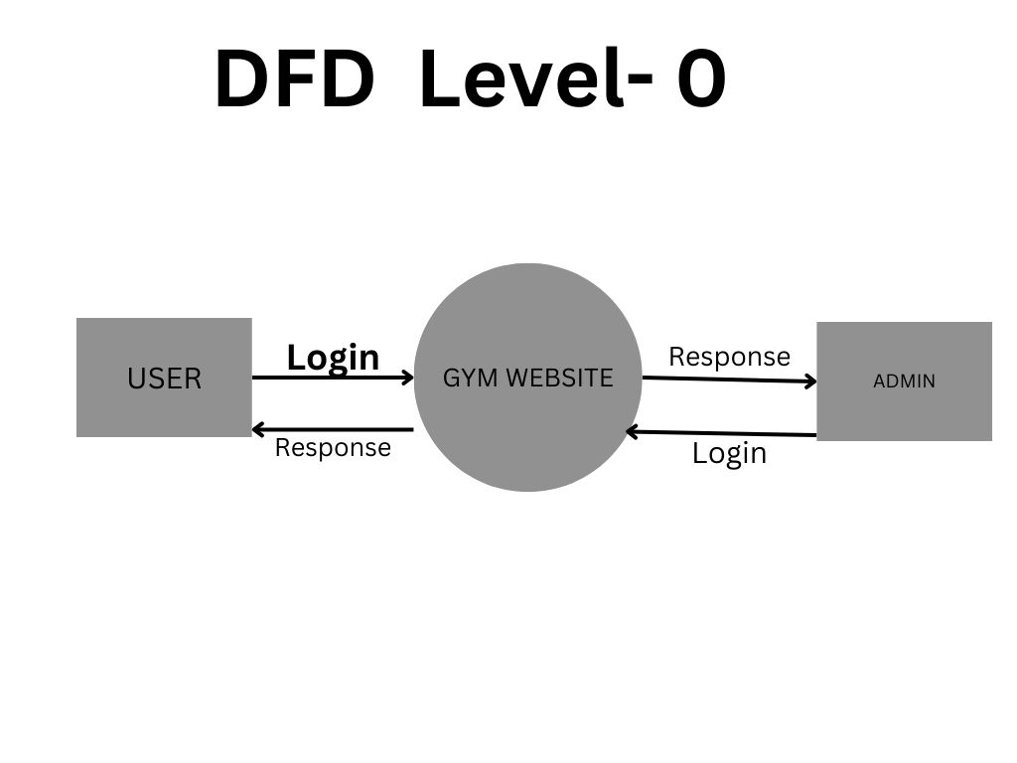

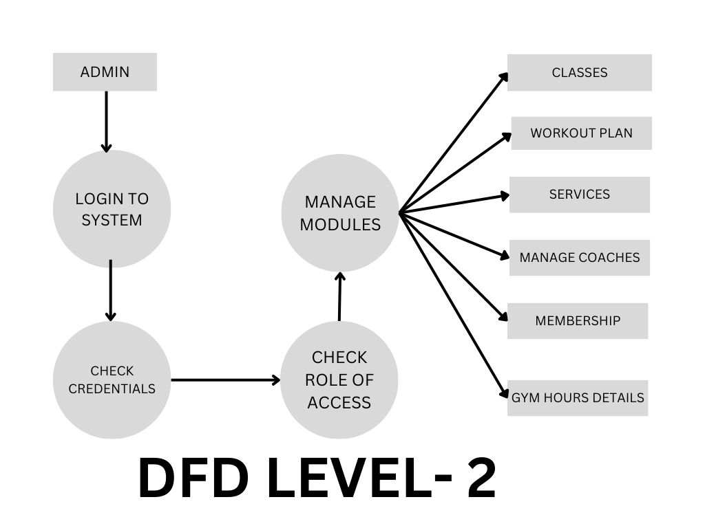

**5.2 Use Case Diagram**

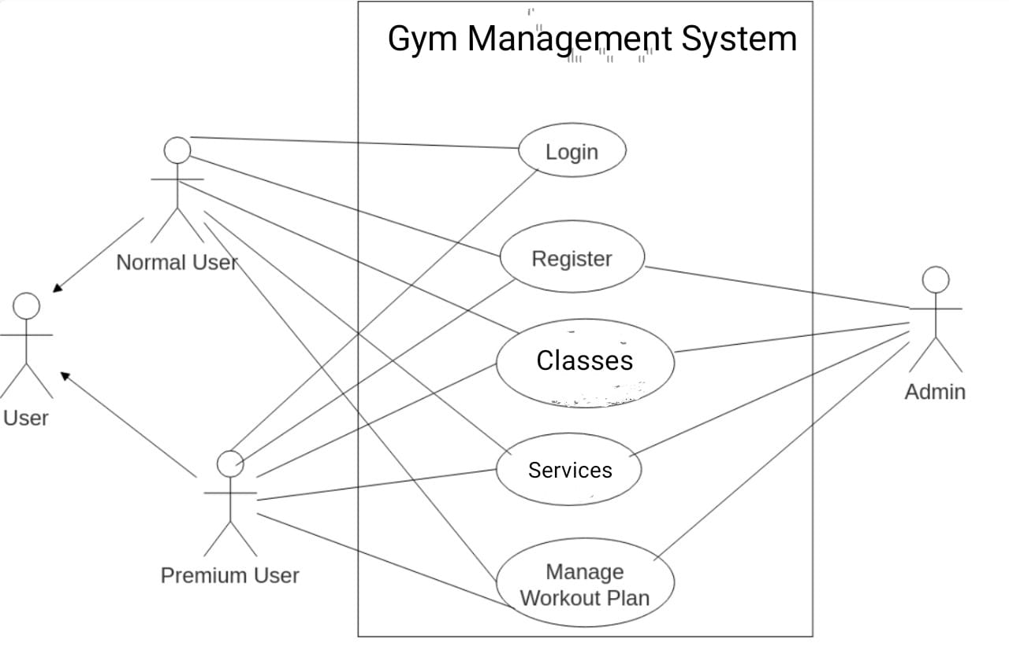

**CHAPTER 6**

**PROJECT OUTCOME**

**6.1 System Features**

* **Secure Login/Signup**: The system incorporates secure user authentication through a login/signup process that protects user data. It ensures that only authorized individuals can access their respective accounts, improving data security and user privacy.
* **Class Schedules and Workout Categories**: The system provides a dynamic schedule of gym classes, allowing users to view and book classes based on availability. The workout categories are organized to help users choose from various fitness regimes, such as strength training, cardio, yoga, and more.
* **Trainer Profiles and Blogs**: Trainers are given personalized profiles where they can list their qualifications, expertise, and schedules. Additionally, trainers can maintain blogs to provide fitness tips, workout routines, and health advice, thus enhancing engagement and establishing trust with gym members.

**6.2 User Interface Overview**

* Intuitive, user-friendly interface with easy navigation.
* Visually appealing design to enhance the user experience.

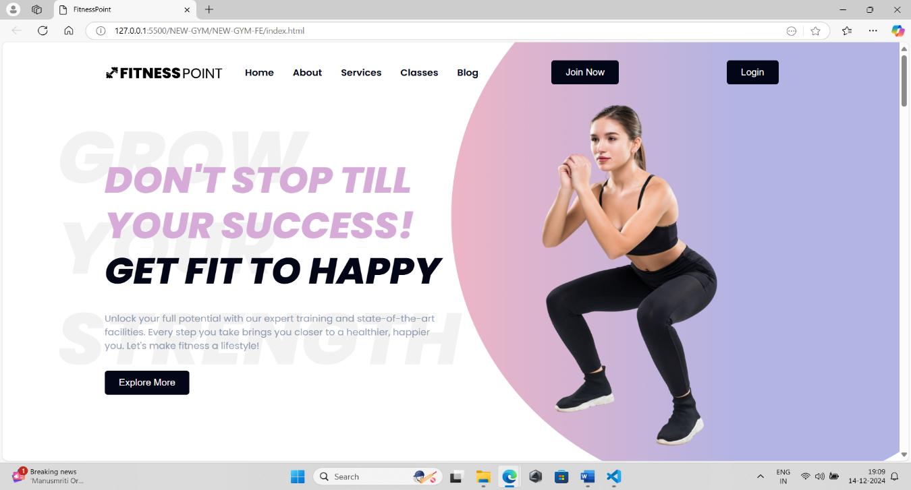**Home page:**

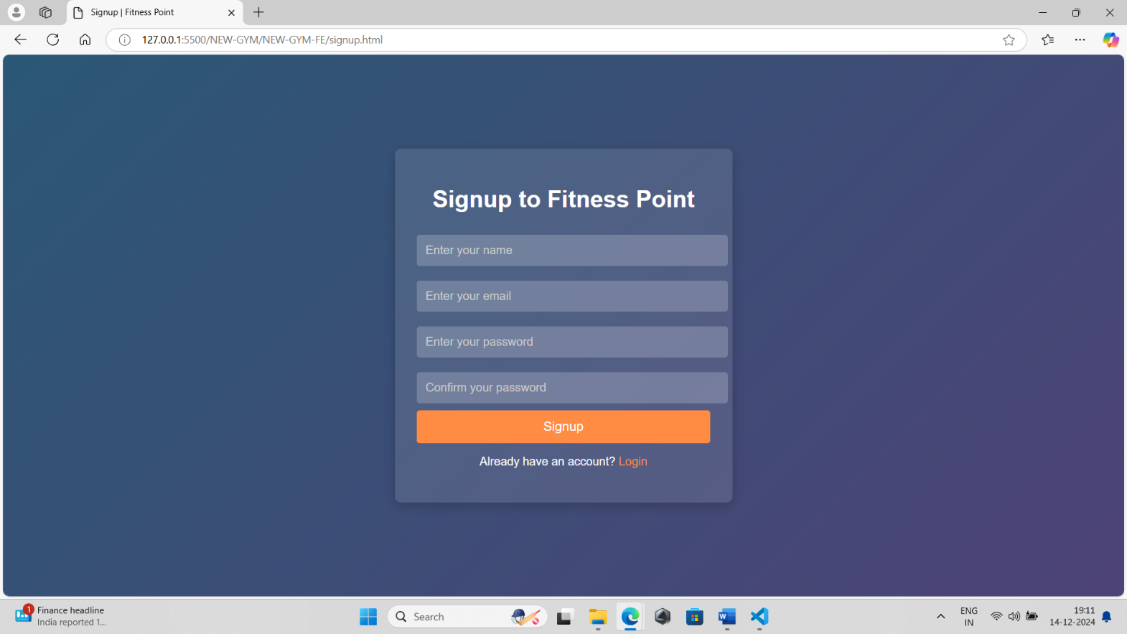**Signup page:**

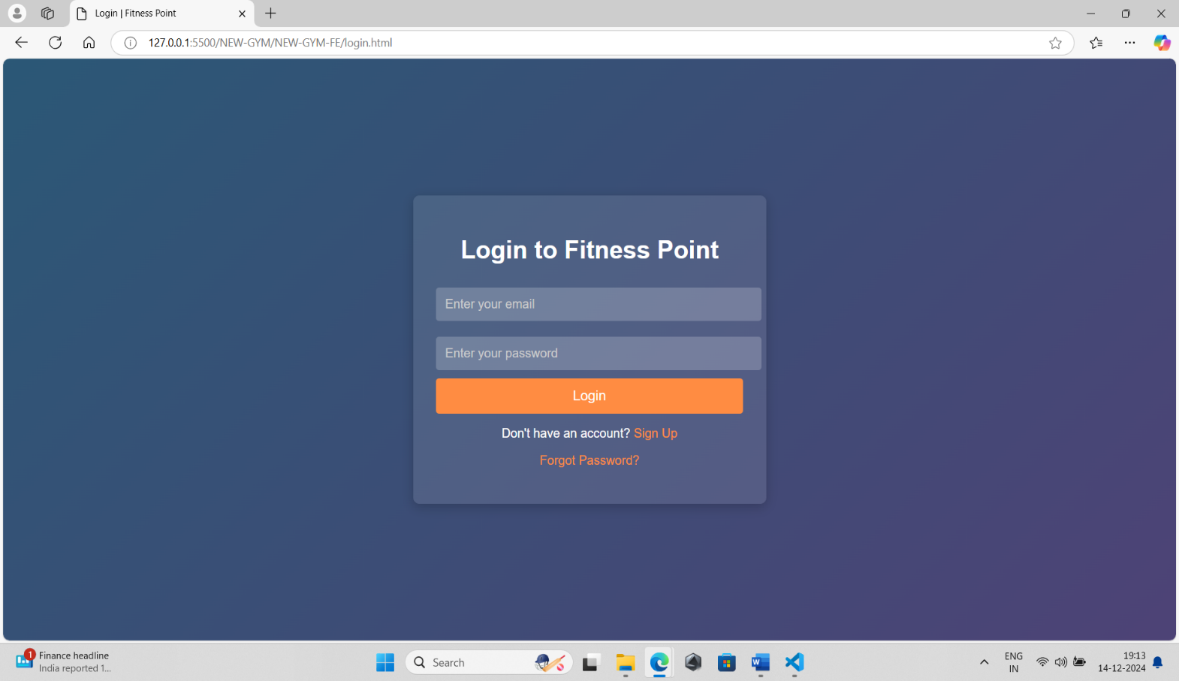**Login page:**

**Services:**

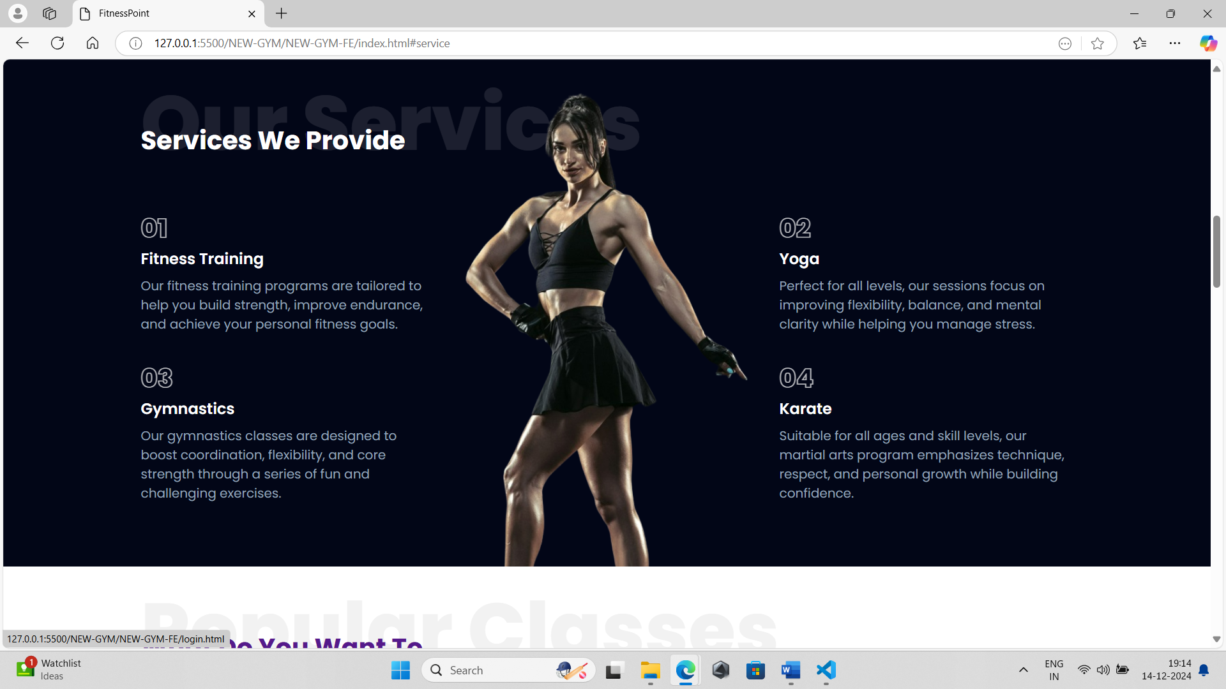

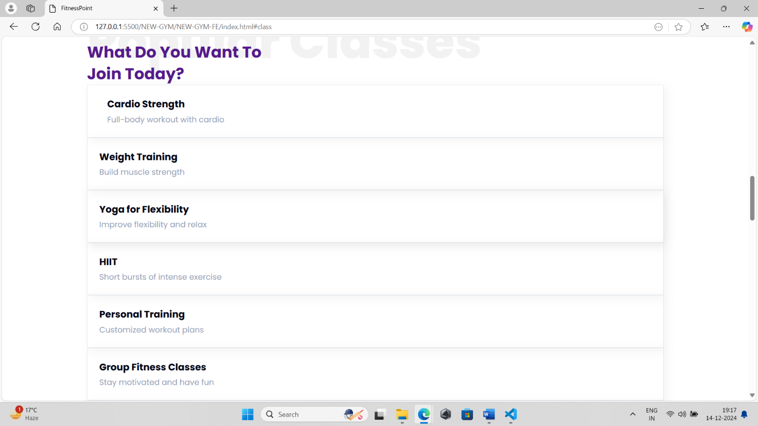**Classes:**

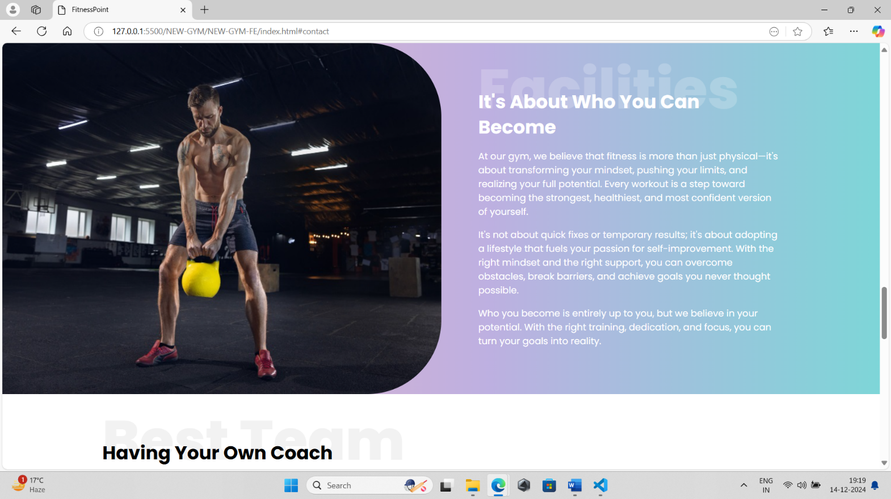**Blog:**

**Trainer info:**

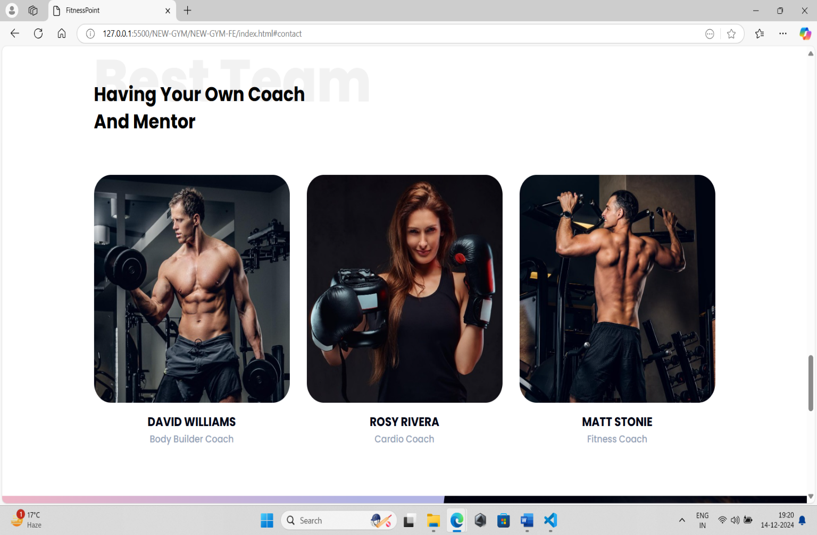

**Contact us:**

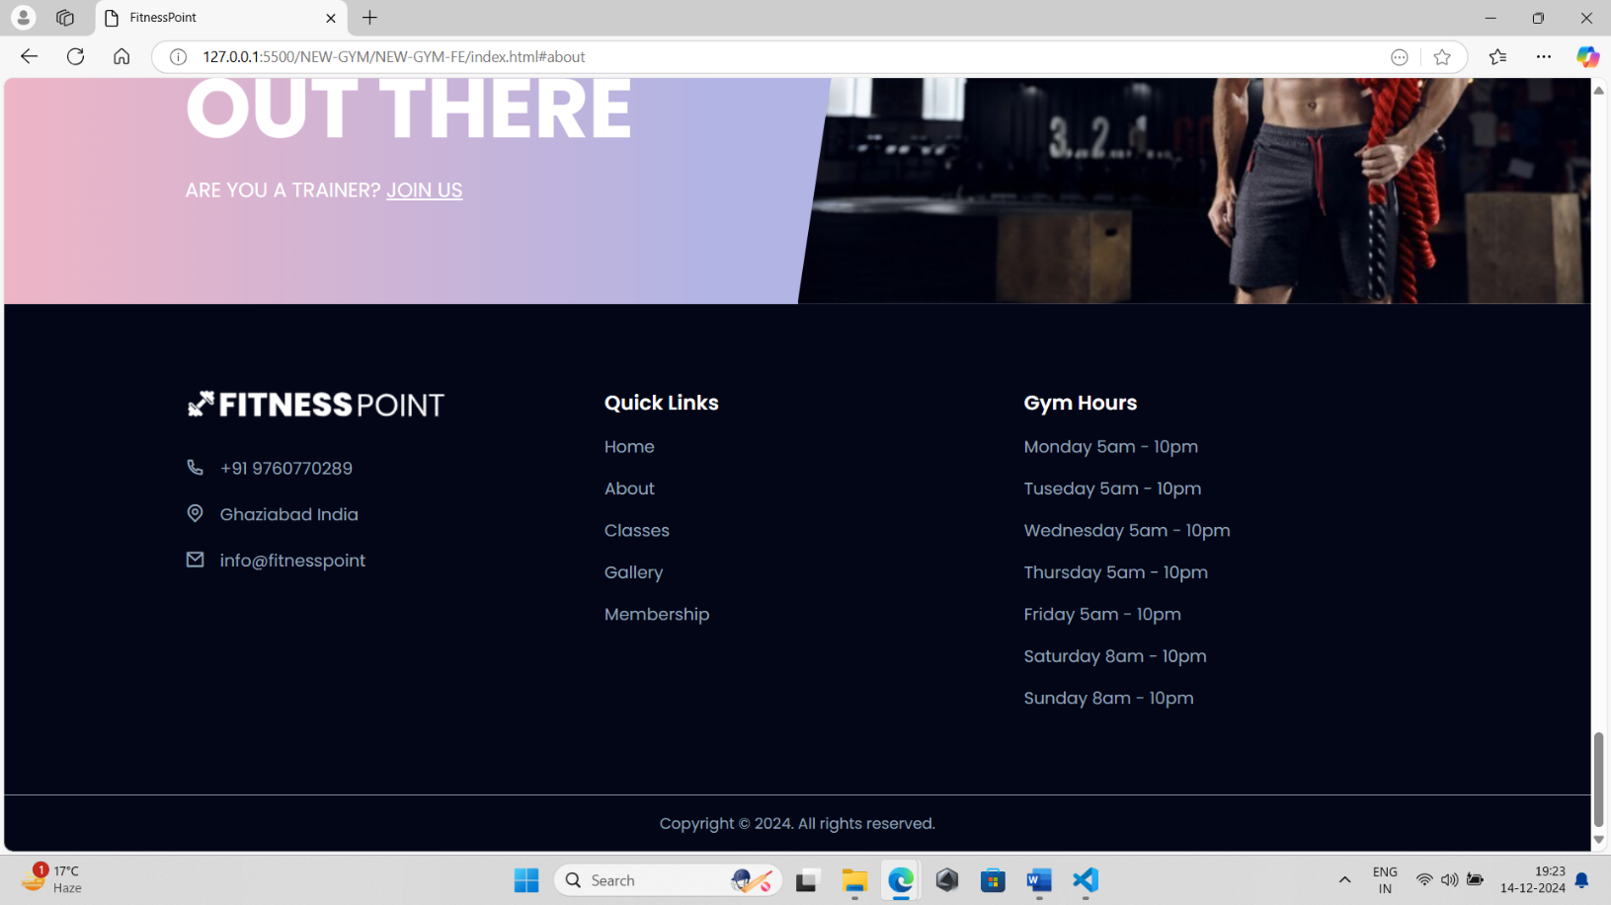

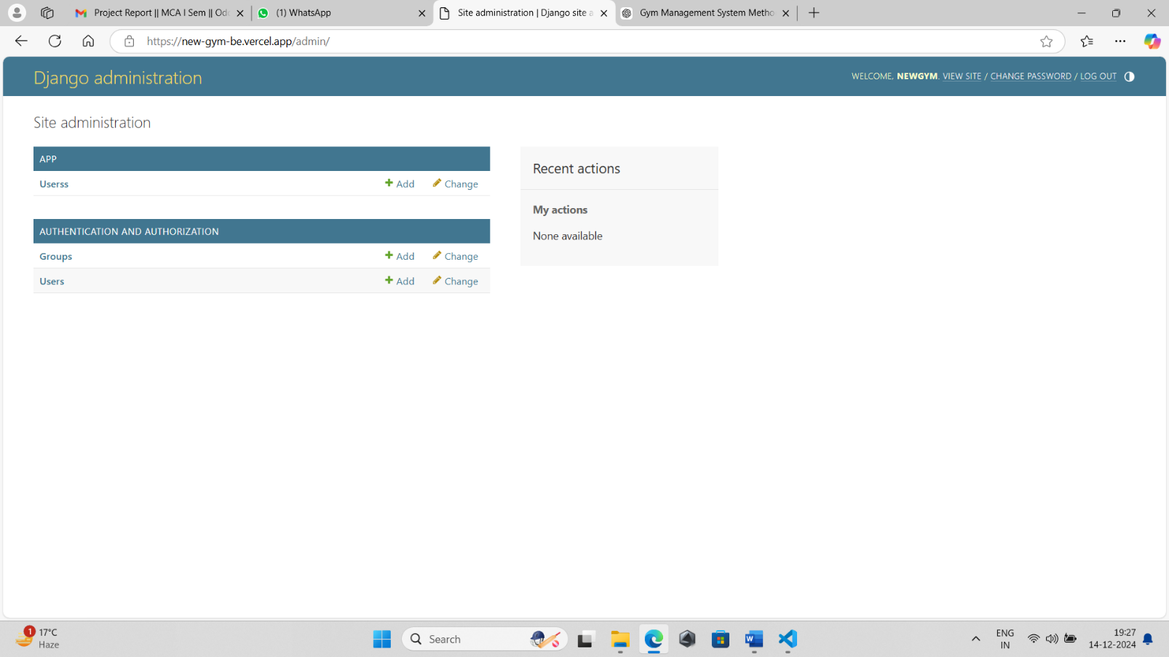**Backend:**

**Users:**

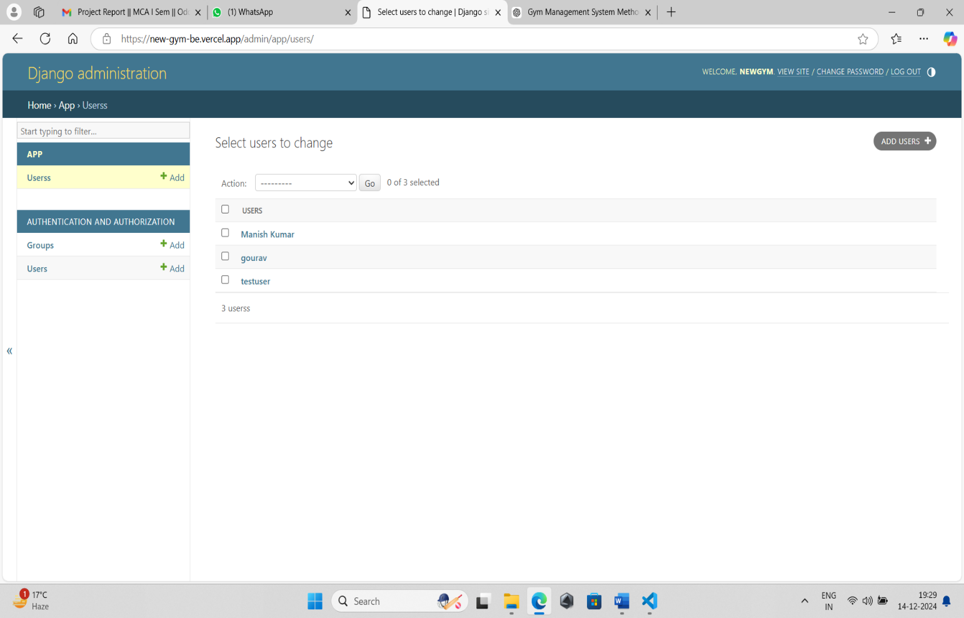

**Manage user:**

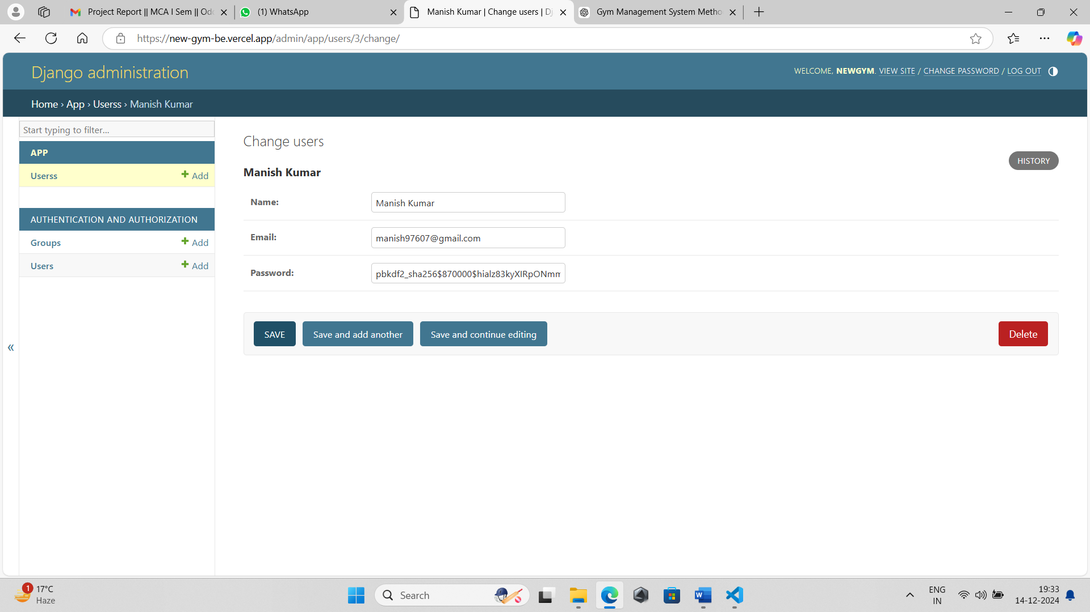

**REFERENCES**

1. M. G. Salazar and J. R. Lopez, "Design and development of a gym management system," Proceedings of the International Conference on Computing and Information Technology, vol. 4, no. 2, pp. 33-38, 2021.
2. K. J. M. Hartmann, "Web-based gym management system using Django," International Journal of Computer Applications, vol. 150, no. 1, pp. 67-72, 2016.
3. "HTML: Hypertext Markup Language," MDN Web Docs. [Online]. Available: <https://developer.mozilla.org/en-US/docs/Web/HTML>. [Accessed: Dec. 14, 2024].
4. "CSS: Cascading Style Sheets," MDN Web Docs. [Online]. Available: <https://developer.mozilla.org/en-US/docs/Web/CSS>. [Accessed: Dec. 14, 2024].
5. "JavaScript: Programming language for the web," MDN Web Docs. [Online]. Available: <https://developer.mozilla.org/en-US/docs/Web/JavaScript>. [Accessed: Dec. 14, 2024].
6. D. S. Lee, "Django web framework for building modern applications," Proceedings of the International Conference on Software Engineering and Development, vol. 2, pp. 150-155, 2020.
7. S. Kumar, A. Sharma, and R. Gupta, "Integration of payment gateway in gym management systems," Journal of Computer Science and Technology, vol. 7, no. 5, pp. 112-118, 2018.
8. "Stripe API documentation," Stripe. [Online]. Available: <https://stripe.com/docs/api>. [Accessed: Dec. 14, 2024].
9. "PayPal REST API," PayPal Developer. [Online]. Available: https://developer.paypal.com/docs/api/overview/. [Accessed: Dec. 14, 2024].
10. R. M. Patel, "Real-time data analytics for gym management," International Journal of Data Science and Analytics, vol. 5, no. 3, pp. 42-47, 2019.